Tired of Looking at the Same Colors on your Web Page? Here’s how you can spice things up!
Color Magic Turns it Around!!!
No more pain in coloring images & making your very own variation of buttons, icons or images. Hassle-free. 100% legit. Use on your website or sales page & increase sales conversion in seconds!!
Online visitors are immediately repelled by images with usual colors and shades. They are rendered ‘blind’ by the visual saturation reached due to excessive web surfing. The colors of your website images do not make any impact. Color Magic turns things around for you! Its unique features and their easy application changes the way you look at your website. The number of options that Color Magic opens up for your website is simply staggering. You can redefine the visual quality of your website with the help of Color Magic!
With the help of this software, you can instantly create colored versions of your website images with a single click.
“Color Magic is an invaluable investment that will magnify your business, your products or services. There is a ton of copycat advertising out there that no one is paying attention to Working with Color Magic is allowing me to stand out and be noticed!…” - Todd Brown
GRAB IT NOW -> 
Color Magic gives you the freedom to change the colors of your web images by a hassle-free method. A single slider control achieves what you’re looking for. Your web visitors get to see excellent images and shades that they will not find on any other website. In fact, the unique colors of Color Magic will attract them to your website even more. They will adore the clutter-breaking images on your website as opposed to dull ones that fail to pass your marketing message to online visitors.
Color Magic is a stand-alone app. You don’t have to buy any other software along with Color Magic.
The Color Magic Advantages
- Instant coloring of different images, buttons and icons
- Easy to use. Non-tech users can use it without any fuss
- Adds uniqueness to your website images
- No associate software required
- Achieves different colors, mirror images and even rotates images for your website
- Can work on both png and jpg files
- Reduces bounce rate and improves lead conversions on your website
- 100% legit
Unique Features of Color Magic
- Coarse & Fine Slider Controls: Allows you to change colors instantly and easily
- Color Intensity Control: Adjust colors between the spectrum of boring and vivid
- Brightness Control: Make images lighter and darker
- Batch Processing: Automatically change the colors of a batch of images using the same settings.
Color Magic Icons
Color Magic can create icons for your website. It can create colored versions of images of the same size or even stretch out to fill the role of larger images.
Color Magic for Facebook
The images on your Facebook timeline get a facelift with Color Magic. You can rotate or flip your Facebook images for a zany effect!
Color Magic Asks No Questions
Color Magic works on a strict money-back policy! If you don’t like what you get from Color Magic, we will refund your money. No questions asked.
Platforms for Color Magic
Color Magic works on all versions of Windows operating systems. No Mac versions are available as of now.
Check out this video to see just how easy it is to use!
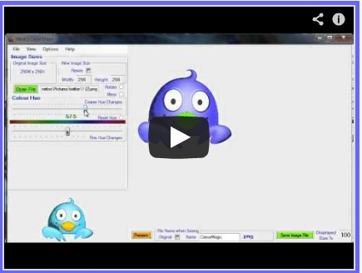
I WANT IT NOW->
You are in good hands! See more what others are saying!
“I wasn't asked to leave a review but I like this program so much I wanted to leave one anyway.For anyone using images in their marketing ( this has to be everyone right?) this little program is so cool. Not only can you change the color of any .jpg or .png image you can re-size them too.How many sales buttons and badges have you purchased over the years but never found just the right color or size for your website or how about changing your header graphic, logo or whatever.There are so many way's to use this software especially if you think outside the box. Hint.. think video production.”
…………………………………………………………….
“Steve, Color Magic is a stroke of genius. It is extremely easy to use and produces great results. It is a steal for the price I was able to grab it, and a godsend for people like me who are not gifted in using highly technical graphics programs. I have all kinds of ideas on its use. Thanks very much.”
…………………………………………………………….
“I just purchased this and I must say I am very impressed with this program. I created colored versions of my Meme Images and they have generated a lot of buzz on both Facebook and Pinterest. For those who are looking for a program to change color, Tint and some amazing transitions, this is the perfect program for them.”
……………………………………………………………..
“I've been experimenting with this software and as of late and to be honest it's a valuable product with awesome execution. It doesn't matter if you're developing your own sales pages, have a blog, or just want to jazz up your latest artwork.. if you don't have awesome graphics (and varying graphics) your content will suck and people won't even read your stuff. (I used to struggle finding new images to post on my pages because I ONLY use images I have the rights to, now the breadth of my image library is expanded exponentially) The hidden beauty is that you can turn your limited quantity of images into a now unrelenting quantity of images and can develop the "perfect" palette of colors for each page you ever develop. I found this very practical and it's VERY easy to use. A+, can't wait to see what else you have in store.”
……………………………………………………………….
“I have purchased this little gem last night. Like many, I often get frustrated looking for the right colors to match my sales /squeeze pages and my theme colors. This is the answer. No more searches I can change colors of any arrows, buttons, or anything else using the magic that Steve offers in this software. As well, often I did not include an image on my site because, because everyone uses it. For example the 3D people. Always white, right. Well, now I can change and fool around with these guys to my heart's desire. I can have them in any color I wish. As I most often buy images this software, will save me a lot of money as I can make the images that are common online unique.”
………………………………………………………………
GRAB IT NOW ->
Check out these sample graphics! Explore lot more inside!!!

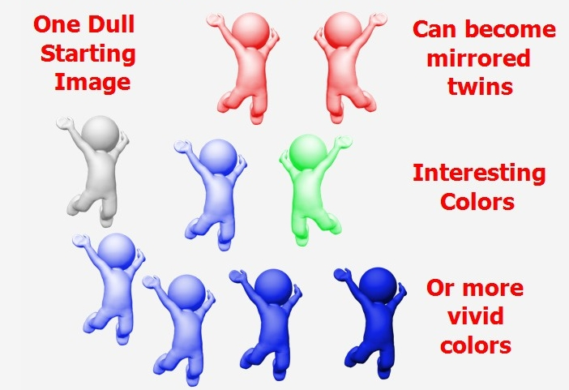
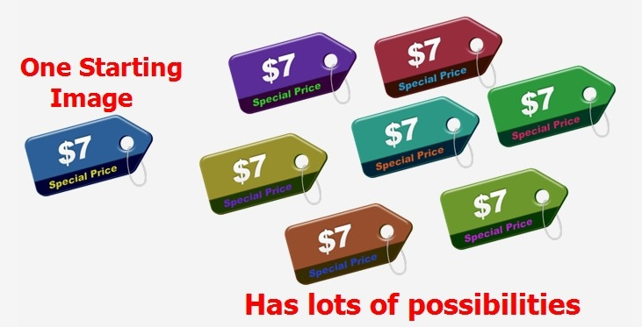

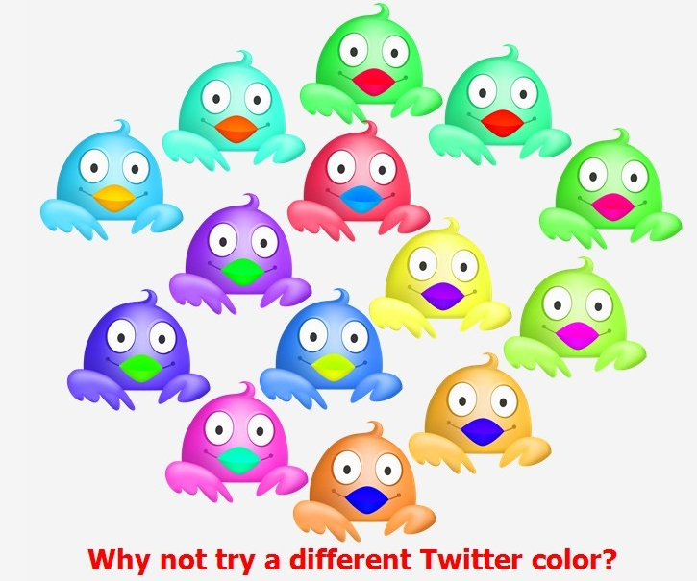
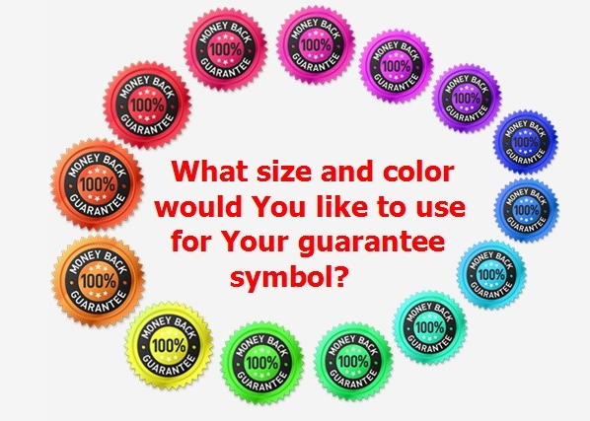

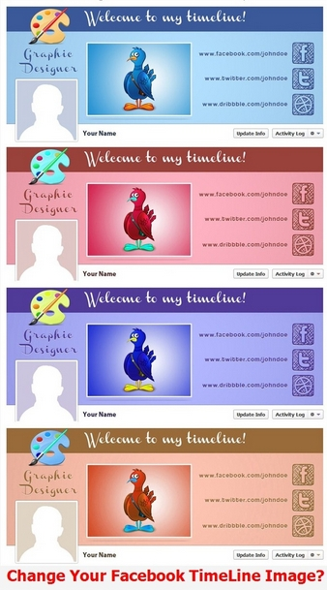
Bonus with Purchases – FREE ..FREE ..FREE
- With every purchase of Color Magic, you will receive bonus images for your website and for those of your clients
- Guarantee symbols
- Call to Action Buttons
- Twitter icons
Pocket Pinch
Color Magic comes at a very affordable price of $27 (Single PC license)! It is surely a small price to pay for the benefits that Color Magic brings along with it. Your website will get a new identity when the magic wand of Color Magic gives it a new hue and tinge.
Grab it now at this small price and make a big difference to your website!
ORDER IT NOW ->

